MACH4METAL

metalworking machinery
Transito 21,
6909 DA BABBERICH
Netherlands
Tel. +31 (0)316 – 247123
Fax. +31 (0)316 - 247956
info@mach4metal.com
www.mach4metal.com

Bank No : 66.52.13.883
IBAN : NL33 INGB 0665 2138 83
BIC : INGBNL2A

HERMLE C40U DYNAMIC 5 Axis
HERMLE pallet storage PW 160
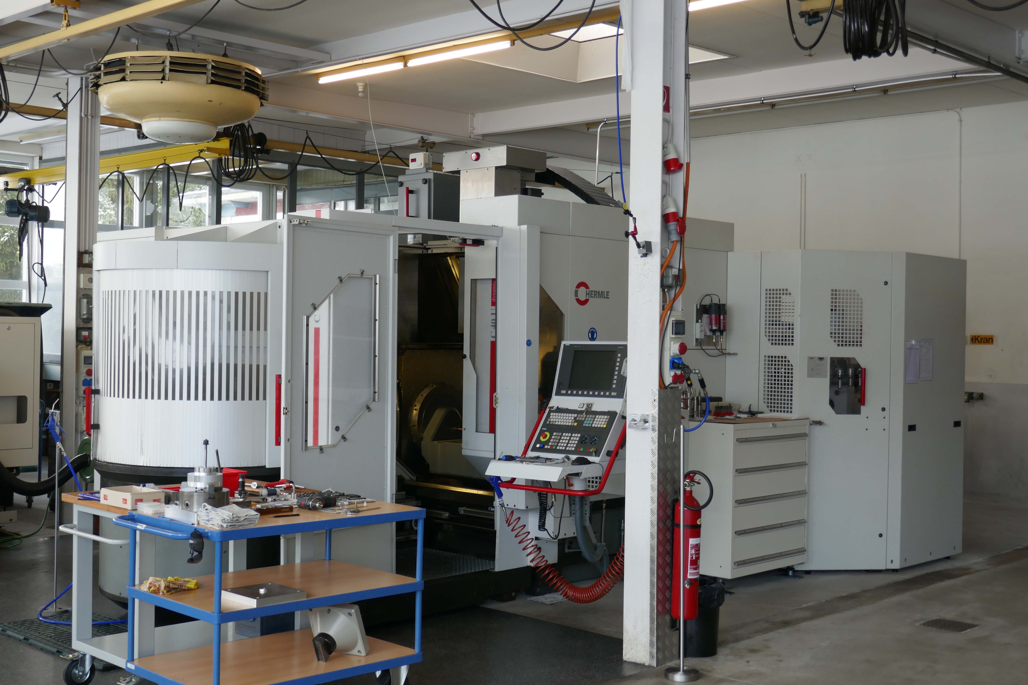
- Make : HERMLE Germany
- Type : C 40 U Dynamic
- Mach. No :
- Age : 2004 / 2016

- Capacity / Working area
- X - Travel : 850
- Y - Travel : 700
- Z - Travel : 500
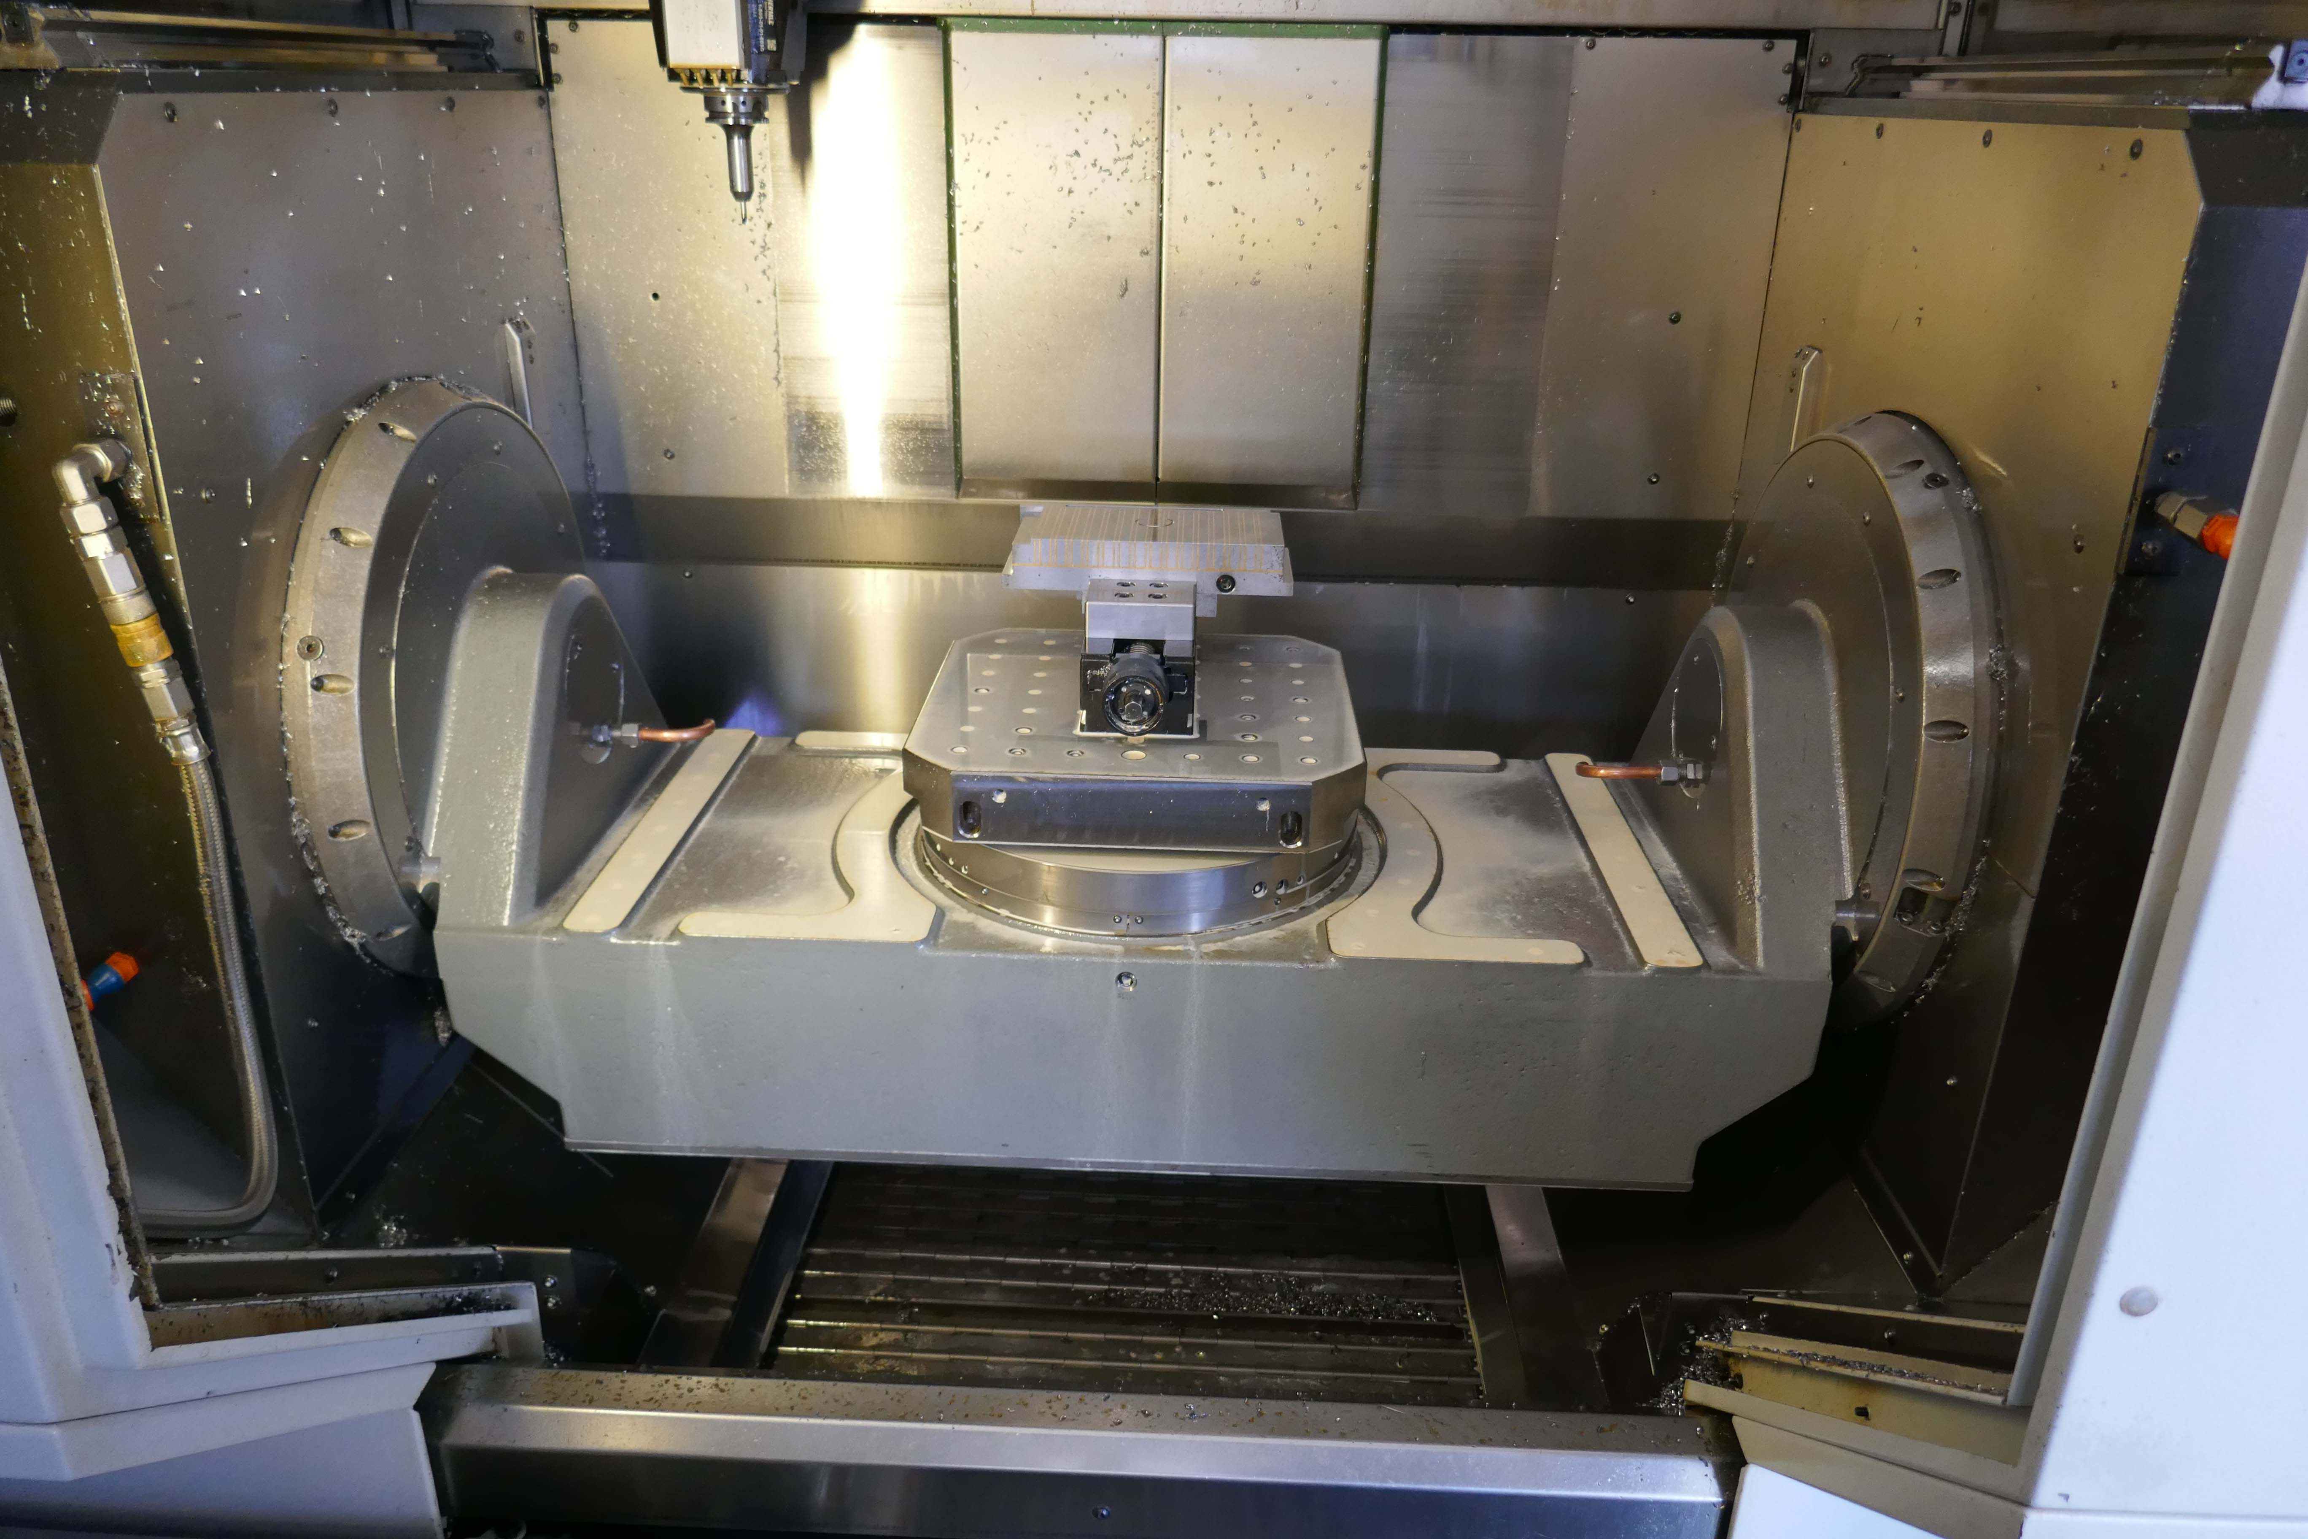

- Table Ø : 700 X 700
- Table load Kg : 800
- Swivel angle : +/- 25 - 110° Gr

- Spindle taper : HSK 63
- Spindle power : 15 kW
- Spindle speeds : 18.000 Rpm
- ATC : 75 ( 32 + 43)
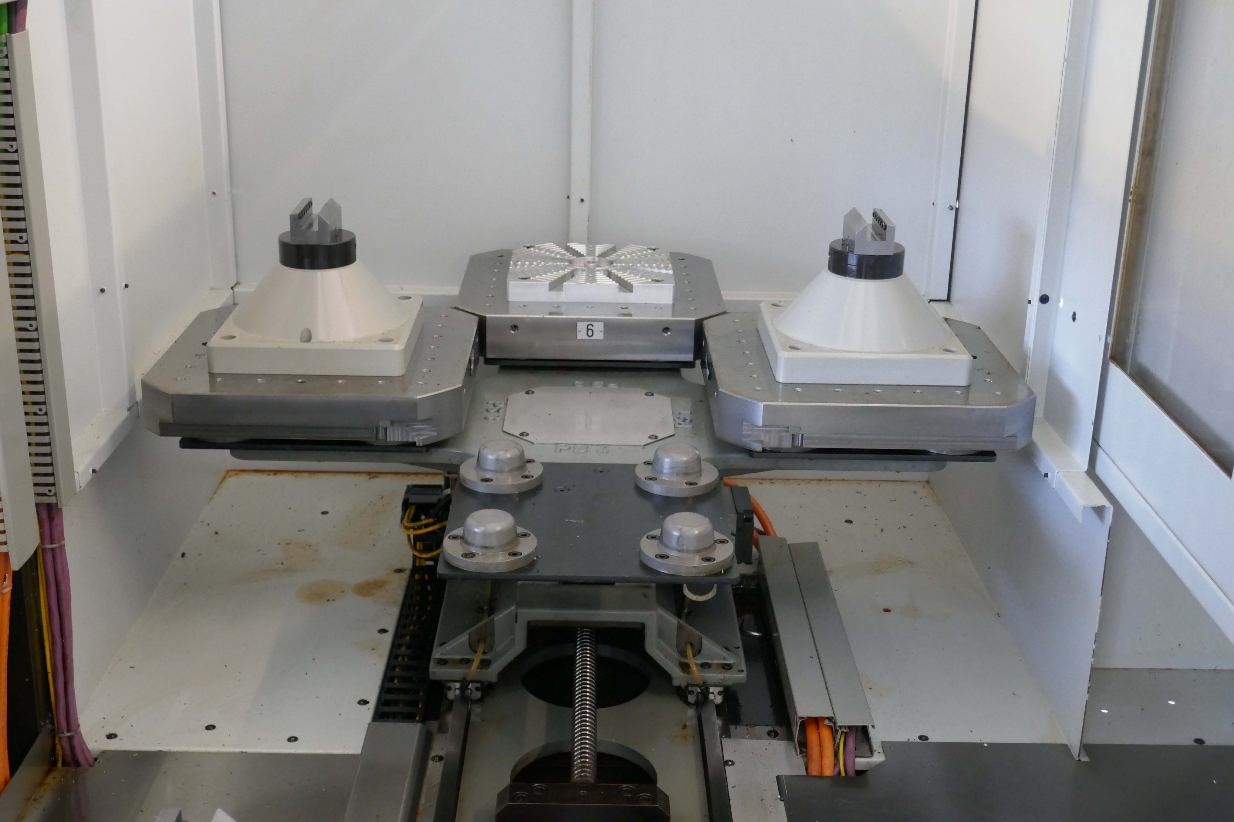
- SIEMENS 840D
- BLUM laser tool
- Renishaw taster

- Hermle PW 160 pallet storage
With pallet changer

- KNOLL IKZ Coolant high pressure
- KNOLL chip conveyor
- Under power in Swiss
- Worked small parts medical Industrie

Please Note: The above information has been obtained to the best of our ability and belief from, and from the manufacturers where possible. It is given in good faith, but its accuracy can not be guaranteed. Accordingly, it will not form a representation or constitute contractual terms. We advise you to check any vital details!

